CARCM Ablation Study

Executive summary
Two complementary ablations on the same architecture, training regime, and random-split test set (n = 4451). The context ablation (8 configs) removes or perturbs the (Variety, Tissue, Stage) context branch to isolate its contribution. The feature-block ablation (4 configs) keeps the context branch intact and removes one of the four sequence-side feature blocks (Binned Motif Counts, Positional Features, Global Motif Counts, Co-occurrence) at a time. Each configuration was trained with 10 seeds; metrics are reported as mean [95% CI] across seeds. DeLong p-values are computed against Full CARCM on the simple-mean ensemble of seeds.

Table 1 — Context ablation
# | Configuration | AUC | PR-AUC | F1 | MCC | ΔAUC vs Seq-only | DeLong p vs Full
1 | Full CARCM (sequence + variety + tissue + stage) | 0.8129 [0.8096, 0.8162] | 0.8354 [0.8313, 0.8395] | 0.7610 [0.7564, 0.7656] | 0.4533 [0.4437, 0.4629] | +0.2021 [+0.1966, +0.2077] | n/a n.s.
2 | Sequence-only (context branch removed) | 0.6107 [0.6076, 0.6139] | 0.6410 [0.6371, 0.6450] | 0.6665 [0.6617, 0.6713] | 0.1202 [0.1117, 0.1286] | +0.0000 [+0.0000, +0.0000] | <1e-300 ****
3 | Sequence + variety only | 0.6657 [0.6629, 0.6685] | 0.6982 [0.6948, 0.7016] | 0.7033 [0.6990, 0.7075] | 0.2174 [0.2067, 0.2281] | +0.0549 [+0.0501, +0.0597] | <1e-300 ****
4 | Sequence + tissue only | 0.7307 [0.7280, 0.7334] | 0.7590 [0.7564, 0.7617] | 0.7195 [0.7164, 0.7227] | 0.3130 [0.3038, 0.3222] | +0.1199 [+0.1163, +0.1236] | <1e-300 ****
5 | Sequence + stage only | 0.6689 [0.6644, 0.6735] | 0.7147 [0.7106, 0.7188] | 0.6919 [0.6884, 0.6954] | 0.1731 [0.1610, 0.1853] | +0.0582 [+0.0537, +0.0627] | <1e-300 ****
6 | Full CARCM with context labels permuted (negative control) | 0.5830 [0.5777, 0.5883] | 0.6278 [0.6234, 0.6322] | 0.6860 [0.6801, 0.6918] | 0.0377 [0.0253, 0.0501] | -0.0278 [-0.0316, -0.0239] | <1e-300 ****
7 | Context-only (no sequence features) | 0.6803 [0.6790, 0.6817] | 0.7222 [0.7215, 0.7229] | 0.7043 [0.7033, 0.7053] | 0.1677 [0.1579, 0.1775] | +0.0696 [+0.0657, +0.0734] | <1e-300 ****
8 | Full CARCM with context branch replaced by param-matched bias | 0.6091 [0.6055, 0.6127] | 0.6408 [0.6369, 0.6448] | 0.6723 [0.6666, 0.6781] | 0.1074 [0.0958, 0.1191] | -0.0016 [-0.0048, +0.0015] | <1e-300 ****

Table 2 — Feature-block ablation (LOO, full context retained)
# | Configuration | AUC | PR-AUC | F1 | MCC | ΔAUC vs Full | DeLong p vs Full
1 | Full CARCM (sequence + variety + tissue + stage) | 0.8129 [0.8096, 0.8162] | 0.8354 [0.8313, 0.8395] | 0.7610 [0.7564, 0.7656] | 0.4533 [0.4437, 0.4629] | +0.0000 [+0.0000, +0.0000] | n/a n.s.
2 | Sequence-only (context branch removed) | 0.6107 [0.6076, 0.6139] | 0.6410 [0.6371, 0.6450] | 0.6665 [0.6617, 0.6713] | 0.1202 [0.1117, 0.1286] | -0.2021 [-0.2077, -0.1966] | <1e-300 ****
7 | Context-only (no sequence features) | 0.6803 [0.6790, 0.6817] | 0.7222 [0.7215, 0.7229] | 0.7043 [0.7033, 0.7053] | 0.1677 [0.1579, 0.1775] | -0.1326 [-0.1354, -0.1297] | <1e-300 ****
9 | Full CARCM minus Binned Motif Counts | 0.7998 [0.7969, 0.8028] | 0.8184 [0.8141, 0.8226] | 0.7482 [0.7447, 0.7517] | 0.4375 [0.4306, 0.4444] | -0.0130 [-0.0176, -0.0084] | 0.0001 ***
10 | Full CARCM minus Positional Features | 0.8076 [0.8045, 0.8108] | 0.8303 [0.8269, 0.8337] | 0.7572 [0.7527, 0.7618] | 0.4456 [0.4333, 0.4579] | -0.0052 [-0.0099, -0.0006] | 0.2645 n.s.
11 | Full CARCM minus Global Motif Counts | 0.8228 [0.8198, 0.8257] | 0.8426 [0.8393, 0.8460] | 0.7662 [0.7642, 0.7682] | 0.4710 [0.4620, 0.4801] | +0.0099 [+0.0052, +0.0147] | 0.4783 n.s.
12 | Full CARCM minus Co-occurrence | 0.8105 [0.8067, 0.8142] | 0.8327 [0.8298, 0.8357] | 0.7580 [0.7539, 0.7621] | 0.4497 [0.4343, 0.4651] | -0.0024 [-0.0088, +0.0041] | 0.7091 n.s.
Significance markers: **** p<1e-4, *** p<1e-3, ** p<1e-2, * p<5e-2, n.s. otherwise.

Conclusions
Full vs. sequence-only: Full CARCM yields AUC = 0.8129 vs. 0.6107 for the sequence-only baseline, ΔAUC = +0.2021 (95% CI [+0.1966, +0.2077]; DeLong p = n/a).
Permuted-label control (row #6): Permuting variety/tissue/stage labels independently in train and test drops AUC to 0.5830 (ΔAUC vs sequence-only = -0.0278; DeLong p vs Full = <1e-300). This is the critical row: a substantial drop confirms the context branch is carrying real signal rather than acting as decorative capacity.
Parameter-matched bias (row #8): Replacing the context branch with a learnable bias vector of equivalent parameter count yields AUC = 0.6091 (ΔAUC vs sequence-only = -0.0016; DeLong p vs Full = <1e-300). The Full CARCM gain is therefore not attributable to extra parameters.

Figures
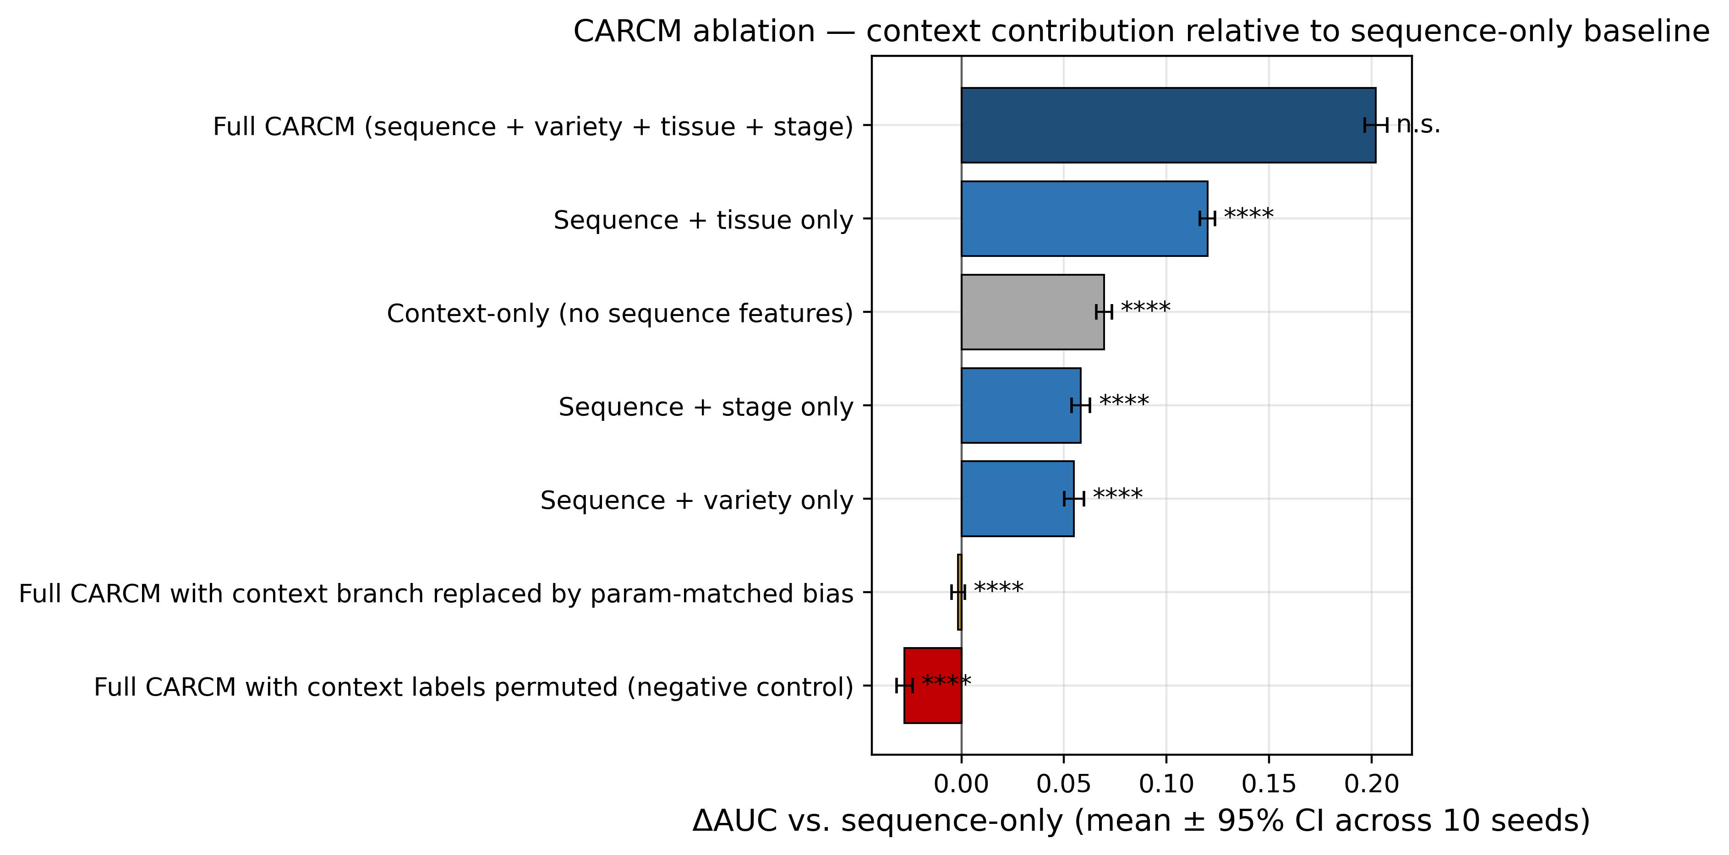
Figure 1. Context ablation — horizontal bar chart of ΔAUC vs. the sequence-only baseline for each context configuration. Bars are paired-seed mean ± 95% CI across 10 seeds. Significance markers (****/***/**/*/n.s.) are DeLong p-values vs. Full CARCM computed on the simple-mean ensemble.
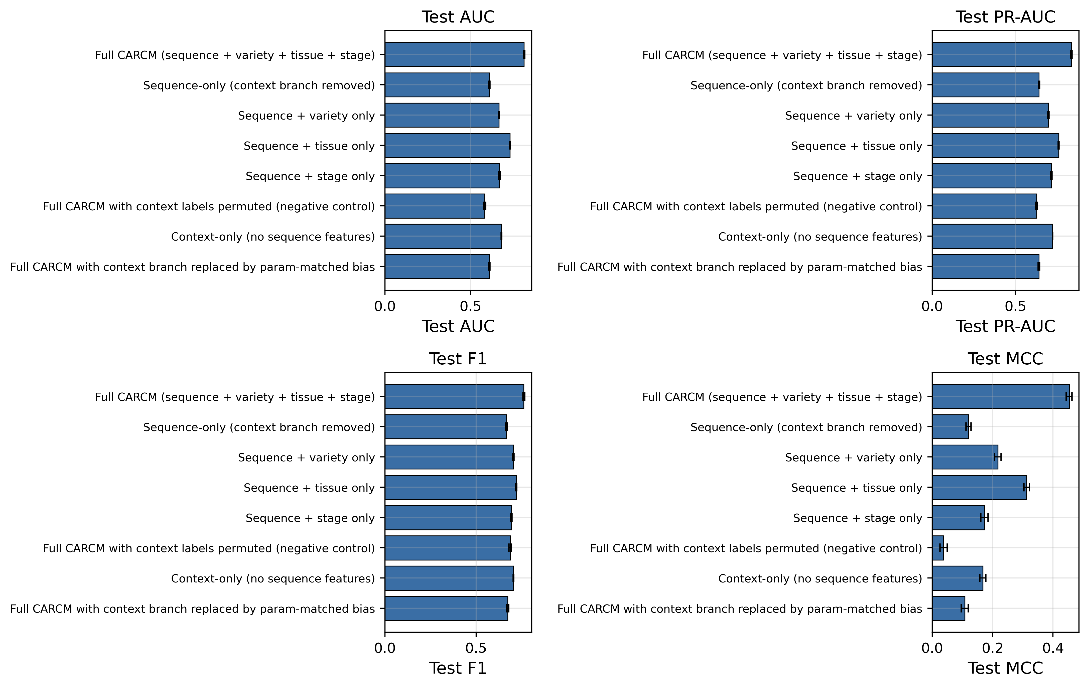
Figure 2. Context ablation — per-configuration mean ± 95% CI for AUC, PR-AUC, F1 and MCC.
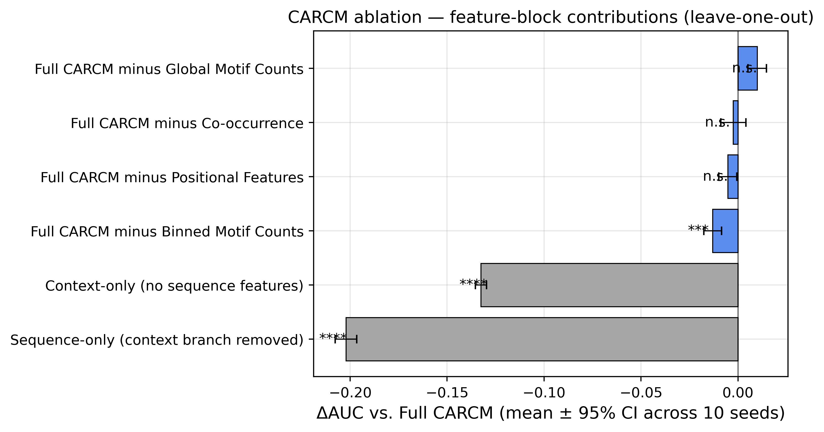
Figure 3. Feature-block ablation — ΔAUC vs. Full CARCM for the four leave-one-out configurations, with sequence-only and context-only anchors. Bars are paired-seed mean ± 95% CI; markers are DeLong p vs. Full.
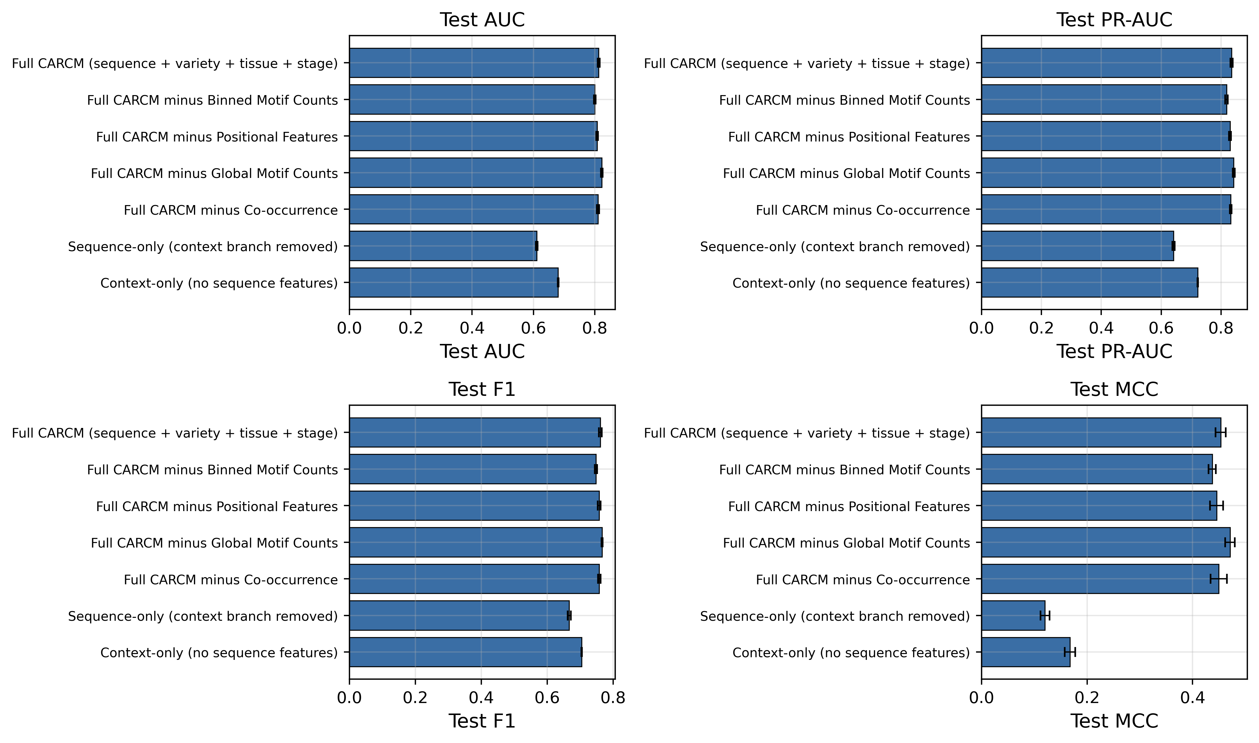
Figure 4. Feature-block ablation — per-configuration mean ± 95% CI for AUC, PR-AUC, F1 and MCC, including Full and the two anchors.

